Analysis of MBA Salaries

NAME: James Rohan Gangavarapu

EMAIL: james.reckon@gmail.com

COLLEGE / COMPANY: Georgia State Univiersity

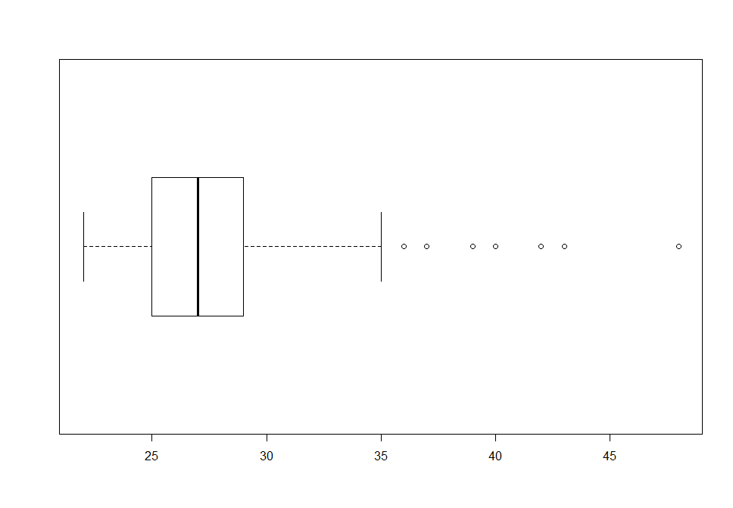

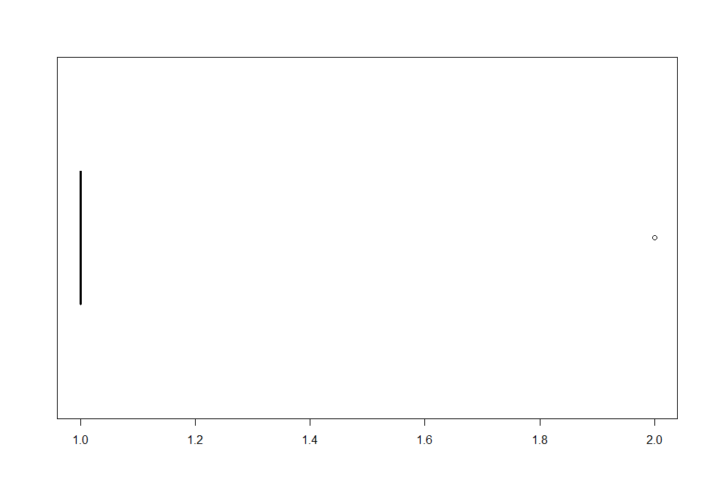

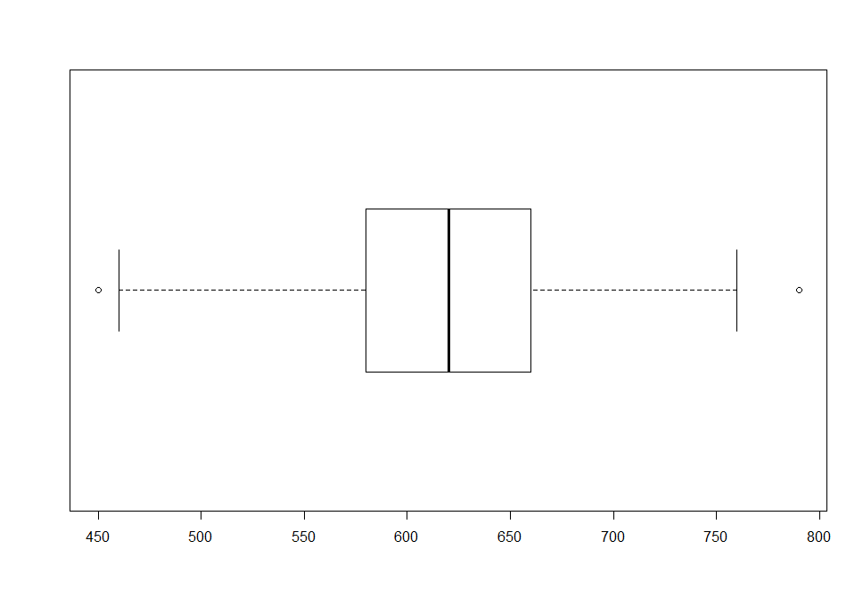

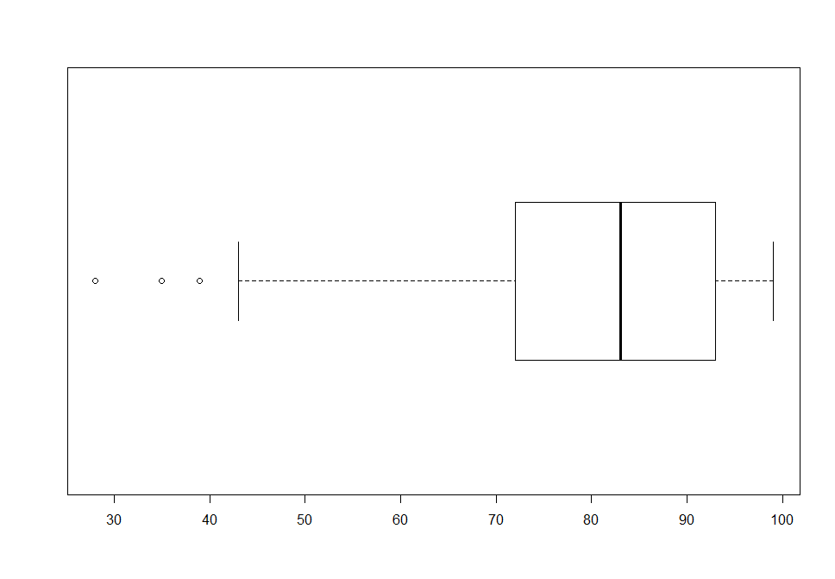

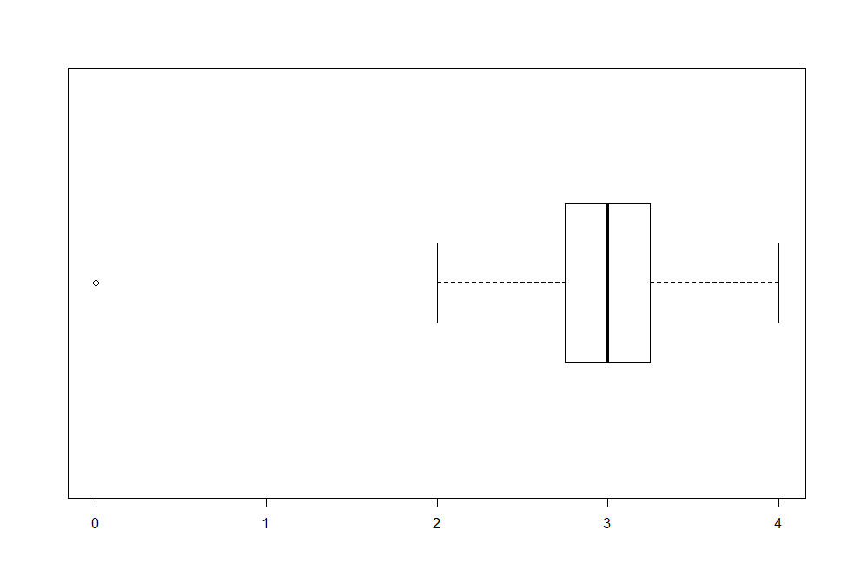

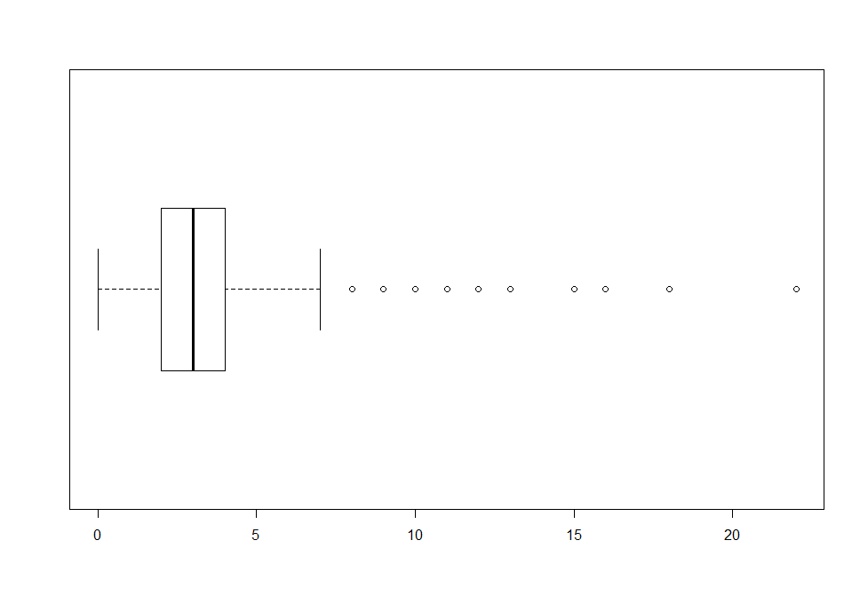

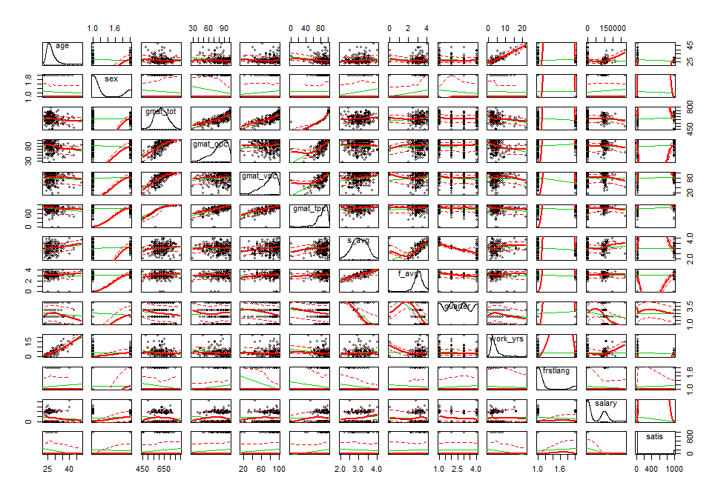

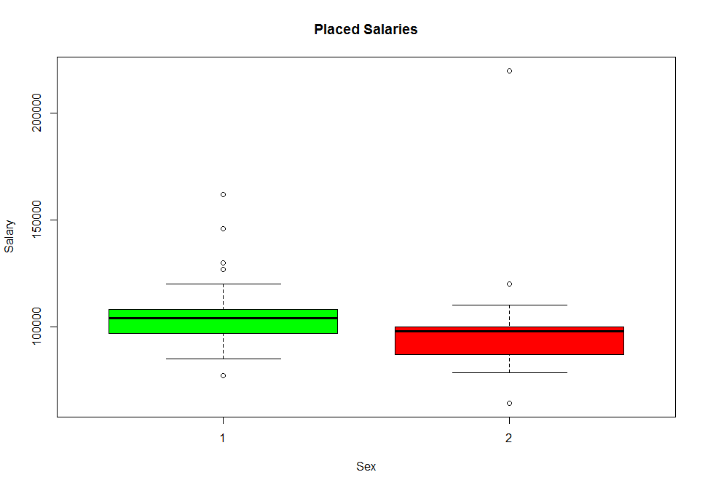

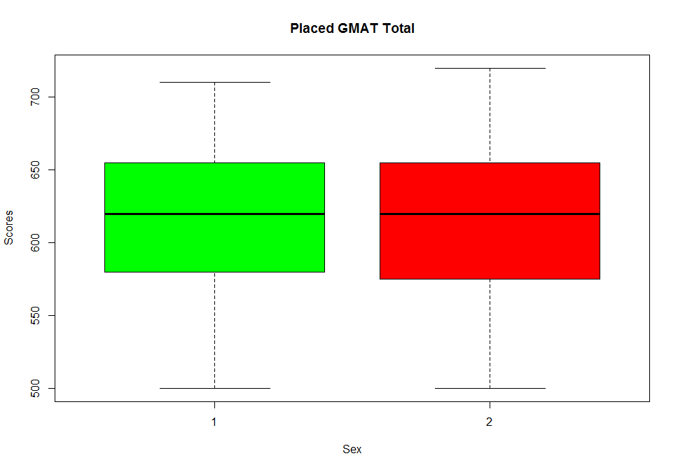

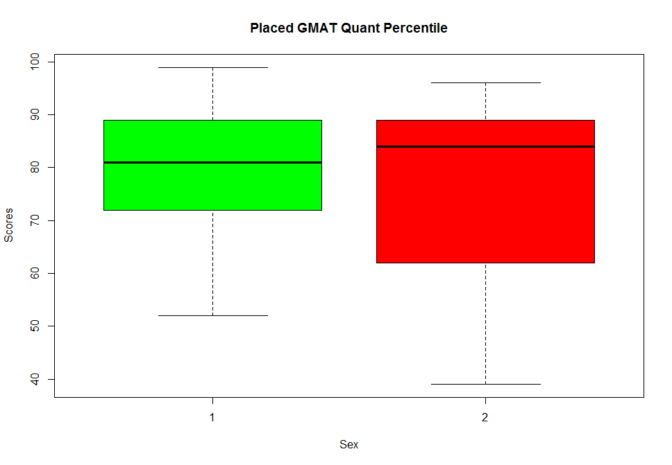

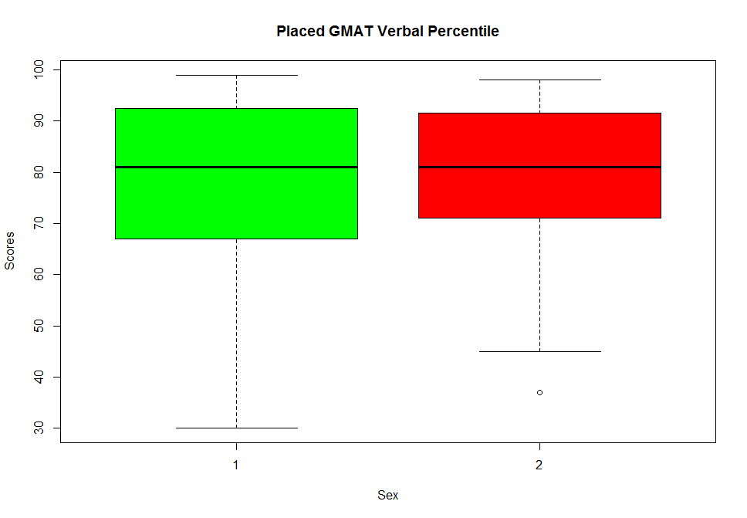

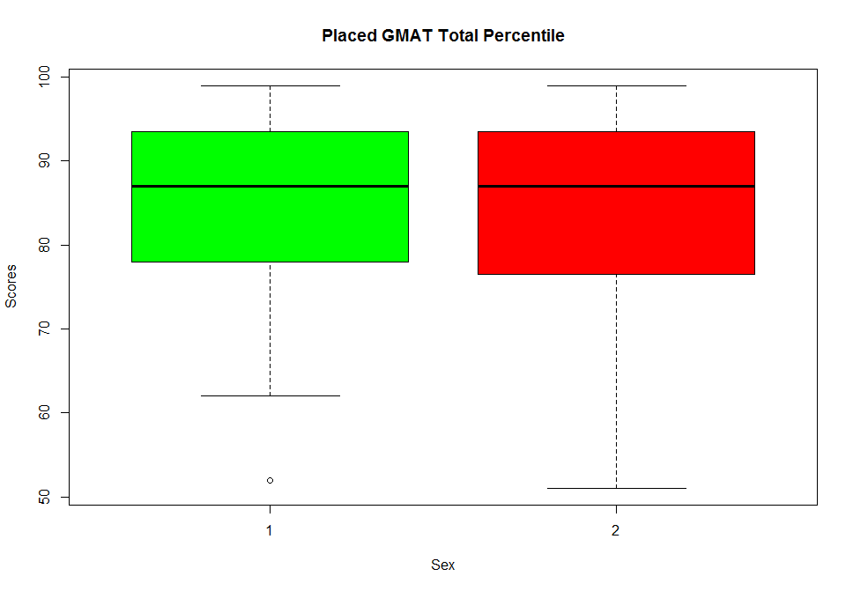

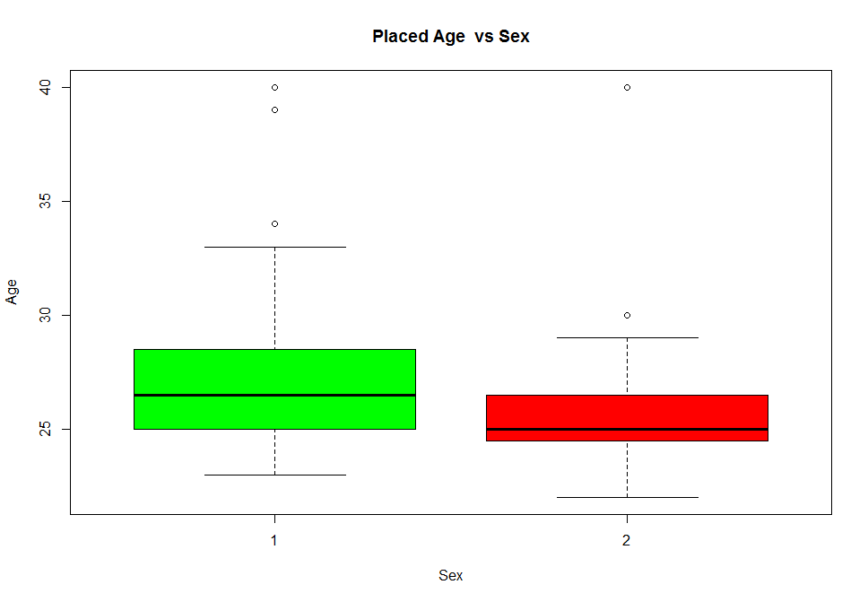

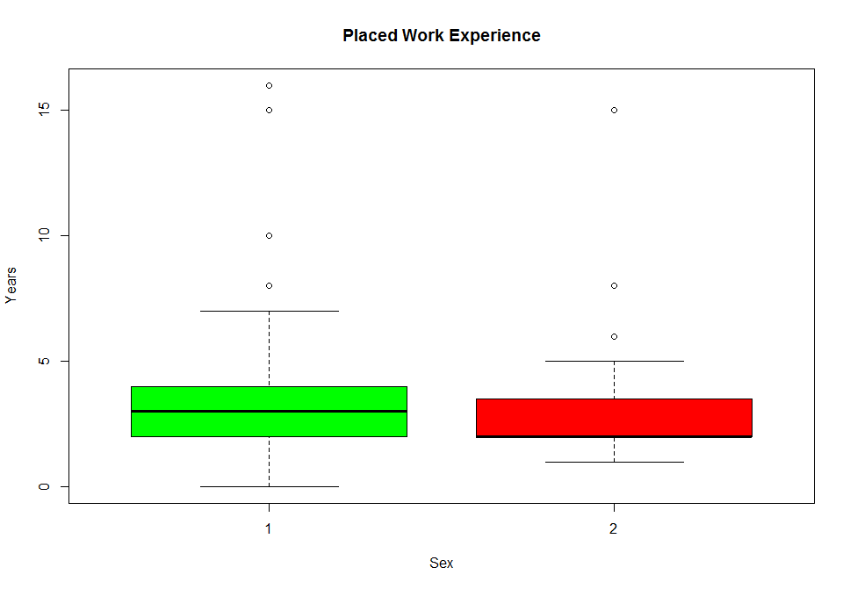

|  |
| --- |
| > meanSalary.tab  sex salary  1 1 104970.97  2 2 98524.39 |
|  |
| |  | | --- | | > | |

|  |
| --- |
| > CrossTable(placed.df$sex, placed.df$satis)    Cell Contents  |-------------------------|  | N |  | Chi-square contribution |  | N / Row Total |  | N / Col Total |  | N / Table Total |  |-------------------------|    Total Observations in Table: 103    | placed.df$satis  placed.df$sex | 3 | 4 | 5 | 6 | 7 | Row Total |  --------------|-----------|-----------|-----------|-----------|-----------|-----------|  1 | 0 | 1 | 17 | 40 | 14 | 72 |  | 0.699 | 0.130 | 0.528 | 0.729 | 0.124 | |  | 0.000 | 0.014 | 0.236 | 0.556 | 0.194 | 0.699 |  | 0.000 | 1.000 | 0.586 | 0.800 | 0.636 | |  | 0.000 | 0.010 | 0.165 | 0.388 | 0.136 | |  --------------|-----------|-----------|-----------|-----------|-----------|-----------|  2 | 1 | 0 | 12 | 10 | 8 | 31 |  | 1.624 | 0.301 | 1.226 | 1.694 | 0.287 | |  | 0.032 | 0.000 | 0.387 | 0.323 | 0.258 | 0.301 |  | 1.000 | 0.000 | 0.414 | 0.200 | 0.364 | |  | 0.010 | 0.000 | 0.117 | 0.097 | 0.078 | |  --------------|-----------|-----------|-----------|-----------|-----------|-----------|  Column Total | 1 | 1 | 29 | 50 | 22 | 103 |  | 0.010 | 0.010 | 0.282 | 0.485 | 0.214 | |  --------------|-----------|-----------|-----------|-----------|-----------|-----------|    > CrossTable(placed.df$sex, placed.df$frstlang)    Cell Contents  |-------------------------|  | N |  | Chi-square contribution |  | N / Row Total |  | N / Col Total |  | N / Table Total |  |-------------------------|    Total Observations in Table: 103    | placed.df$frstlang  placed.df$sex | 1 | 2 | Row Total |  --------------|-----------|-----------|-----------|  1 | 68 | 4 | 72 |  | 0.012 | 0.163 | |  | 0.944 | 0.056 | 0.699 |  | 0.708 | 0.571 | |  | 0.660 | 0.039 | |  --------------|-----------|-----------|-----------|  2 | 28 | 3 | 31 |  | 0.028 | 0.379 | |  | 0.903 | 0.097 | 0.301 |  | 0.292 | 0.429 | |  | 0.272 | 0.029 | |  --------------|-----------|-----------|-----------|  Column Total | 96 | 7 | 103 |  | 0.932 | 0.068 | |  --------------|-----------|-----------|-----------| |
|  |
| |  | | --- | | > | |

> meanGMAT_TPC.tab <- aggregate(gmat_tpc~ sex, data=placed.df, mean)

> meanGMAT_TPC.tab

sex gmat_tpc

1 1 84.86111

2 2 83.74194

> meanGMAT_VPC.tab <- aggregate(gmat_vpc~ sex, data=placed.df, mean)

> meanGMAT_VPC.tab

sex gmat_vpc

1 1 78.00000

2 2 79.87097

|  |
| --- |
| > meanQuarter.tab <- aggregate(quarter~ sex, data=placed.df, mean)  > meanQuarter.tab  sex quarter  1 1 2.277778  2 2 2.225806  > CrossTable(placed.df$sex, placed.df$quarter)    Cell Contents  |-------------------------|  | N |  | Chi-square contribution |  | N / Row Total |  | N / Col Total |  | N / Table Total |  |-------------------------|    Total Observations in Table: 103    | placed.df$quarter  placed.df$sex | 1 | 2 | 3 | 4 | Row Total |  --------------|-----------|-----------|-----------|-----------|-----------|  1 | 23 | 19 | 17 | 13 | 72 |  | 0.088 | 0.133 | 0.003 | 0.006 | |  | 0.319 | 0.264 | 0.236 | 0.181 | 0.699 |  | 0.657 | 0.760 | 0.708 | 0.684 | |  | 0.223 | 0.184 | 0.165 | 0.126 | |  --------------|-----------|-----------|-----------|-----------|-----------|  2 | 12 | 6 | 7 | 6 | 31 |  | 0.204 | 0.309 | 0.007 | 0.014 | |  | 0.387 | 0.194 | 0.226 | 0.194 | 0.301 |  | 0.343 | 0.240 | 0.292 | 0.316 | |  | 0.117 | 0.058 | 0.068 | 0.058 | |  --------------|-----------|-----------|-----------|-----------|-----------|  Column Total | 35 | 25 | 24 | 19 | 103 |  | 0.340 | 0.243 | 0.233 | 0.184 | |  --------------|-----------|-----------|-----------|-----------|-----------|    >  > meanWorkYrs.tab <- aggregate(work_yrs~ sex, data=placed.df, mean)  > meanWorkYrs.tab  sex work_yrs  1 1 3.861111  2 2 3.258065 |
|  |
| |  | | --- | | > | |

|  |
| --- |
| > #LinearRegression Model. StartSal=  > StartSalLM <- lm(salary~sex+gmat_qpc+gmat_tot+gmat_tpc+gmat_vpc+s_avg+f_avg  + +quarter+work_yrs+frstlang+satis, data = MBASal.df)  > StartSalLM  Call:  lm(formula = salary ~ sex + gmat_qpc + gmat_tot + gmat_tpc +  gmat_vpc + s_avg + f_avg + quarter + work_yrs + frstlang +  satis, data = MBASal.df)  Coefficients:  (Intercept) sex gmat_qpc gmat_tot gmat_tpc gmat_vpc s_avg f_avg quarter  158688.16 2804.40 399.37 -311.02 625.23 258.93 7203.61 -6267.05 -7141.31  work_yrs frstlang satis  -825.02 -8508.61 -45.57  >  > ###Second Linear Model(StartSalLM_2) is based on the findings from CrossTable and aggregate functions.  > StartSalLM_2 <- lm(salary~sex+gmat_qpc+gmat_tot+gmat_tpc+gmat_vpc  + +quarter+work_yrs+frstlang, data = MBASal.df)  > StartSalLM_2  Call:  lm(formula = salary ~ sex + gmat_qpc + gmat_tot + gmat_tpc +  gmat_vpc + quarter + work_yrs + frstlang, data = MBASal.df)  Coefficients:  (Intercept) sex gmat_qpc gmat_tot gmat_tpc gmat_vpc quarter work_yrs frstlang  166995.3 5309.3 463.5 -324.8 548.1 237.6 -7459.7 -166.2 -14706.1  >  >  >  > #Checking the Accuracy of Linear Models 1 and 2  > confint(StartSalLM)  2.5 % 97.5 %  (Intercept) 17582.81637 299793.51276  sex -10792.10457 16400.90088  gmat_qpc -749.45304 1548.19504  gmat_tot -726.39777 104.36642  gmat_tpc -198.48076 1448.94869  gmat_vpc -834.55347 1352.41755  s_avg -18058.88926 32466.09952  f_avg -19457.44095 6923.33711  quarter -15072.12838 789.50440  work_yrs -2673.60082 1023.56030  frstlang -28623.85601 11606.63929  satis -61.09229 -30.03907  > summary(StartSalLM)  Call:  lm(formula = salary ~ sex + gmat_qpc + gmat_tot + gmat_tpc +  gmat_vpc + s_avg + f_avg + quarter + work_yrs + frstlang +  satis, data = MBASal.df)  Residuals:  Min 1Q Median 3Q Max  -68179 -41842 -3627 43625 201166  Coefficients:  Estimate Std. Error t value Pr(>|t|)  (Intercept) 158688.165 71661.284 2.214 0.0277 *  sex 2804.398 6905.074 0.406 0.6850  gmat_qpc 399.371 583.438 0.685 0.4943  gmat_tot -311.016 210.955 -1.474 0.1416  gmat_tpc 625.234 418.329 1.495 0.1362  gmat_vpc 258.932 555.334 0.466 0.6414  s_avg 7203.605 12829.725 0.561 0.5750  f_avg -6267.052 6698.826 -0.936 0.3504  quarter -7141.312 4027.718 -1.773 0.0774 .  work_yrs -825.020 938.814 -0.879 0.3803  frstlang -8508.608 10215.662 -0.833 0.4057  satis -45.566 7.885 -5.779 2.13e-08 ***  ---  Signif. codes: 0 ‘***’ 0.001 ‘**’ 0.01 ‘*’ 0.05 ‘.’ 0.1 ‘ ’ 1  Residual standard error: 47580 on 262 degrees of freedom  Multiple R-squared: 0.1633, Adjusted R-squared: 0.1281  F-statistic: 4.647 on 11 and 262 DF, p-value: 1.765e-06  > confint(StartSalLM_2)  2.5 % 97.5 %  (Intercept) 46585.8413 287404.7087  sex -9021.5484 19640.1793  gmat_qpc -751.9397 1678.9211  gmat_tot -763.6115 114.0911  gmat_tpc -321.0631 1417.2201  gmat_vpc -917.1712 1392.3007  quarter -13022.8716 -1896.4483  work_yrs -2089.6254 1757.2271  frstlang -35848.8672 6436.7263  > summary(StartSalLM_2)  Call:  lm(formula = salary ~ sex + gmat_qpc + gmat_tot + gmat_tpc +  gmat_vpc + quarter + work_yrs + frstlang, data = MBASal.df)  Residuals:  Min 1Q Median 3Q Max  -61512 -38737 -26400 51291 200058  Coefficients:  Estimate Std. Error t value Pr(>|t|)  (Intercept) 166995.3 61153.9 2.731 0.00674 **  sex 5309.3 7278.4 0.729 0.46636  gmat_qpc 463.5 617.3 0.751 0.45342  gmat_tot -324.8 222.9 -1.457 0.14628  gmat_tpc 548.1 441.4 1.242 0.21548  gmat_vpc 237.6 586.5 0.405 0.68575  quarter -7459.7 2825.5 -2.640 0.00878 **  work_yrs -166.2 976.9 -0.170 0.86504  frstlang -14706.1 10738.1 -1.370 0.17199  ---  Signif. codes: 0 ‘***’ 0.001 ‘**’ 0.01 ‘*’ 0.05 ‘.’ 0.1 ‘ ’ 1  Residual standard error: 50350 on 265 degrees of freedom  Multiple R-squared: 0.05223, Adjusted R-squared: 0.02362  F-statistic: 1.825 on 8 and 265 DF, p-value: 0.0725 |
|  |
| |  | | --- | | > | |

|  |
| --- |
| > boxplot(placed.df$salary,main = "Placed Salaries", xlab = "Sex"  + ,col = (c("green")), ylab = "Salary")  > boxplot(placed.df$salary~placed.df$sex,main = "Placed Salaries", xlab = "Sex"  + ,col = (c("green","red")), ylab = "Salary")  > library(psych)  > describe(placed.df)  vars n mean sd median trimmed mad min max range skew kurtosis se  age 1 103 26.78 3.27 2.60e+01 26.30 2.97 22.0 40 18.0 1.92 4.90 0.32  sex 2 103 1.30 0.46 1.00e+00 1.25 0.00 1.0 2 1.0 0.86 -1.28 0.05  gmat_tot 3 103 616.02 50.69 6.20e+02 615.90 59.30 500.0 720 220.0 0.01 -0.69 4.99  gmat_qpc 4 103 79.73 13.39 8.20e+01 81.05 13.34 39.0 99 60.0 -0.81 0.17 1.32  gmat_vpc 5 103 78.56 16.14 8.10e+01 80.33 16.31 30.0 99 69.0 -0.87 0.21 1.59  gmat_tpc 6 103 84.52 11.01 8.70e+01 85.60 11.86 51.0 99 48.0 -0.84 0.19 1.08  s_avg 7 103 3.09 0.38 3.10e+00 3.10 0.44 2.2 4 1.8 -0.13 -0.61 0.04  f_avg 8 103 3.09 0.49 3.25e+00 3.13 0.37 0.0 4 4.0 -2.52 13.86 0.05  quarter 9 103 2.26 1.12 2.00e+00 2.20 1.48 1.0 4 3.0 0.27 -1.34 0.11  work_yrs 10 103 3.68 3.01 3.00e+00 3.11 1.48 0.0 16 16.0 2.48 6.83 0.30  frstlang 11 103 1.07 0.25 1.00e+00 1.00 0.00 1.0 2 1.0 3.38 9.54 0.02  salary 12 103 103030.74 17868.80 1.00e+05 101065.06 7413.00 64000.0 220000 156000.0 3.18 17.16 1760.67  satis 13 103 5.88 0.78 6.00e+00 5.89 1.48 3.0 7 4.0 -0.40 0.44 0.08 |
|  |
| |  | | --- | |  | |

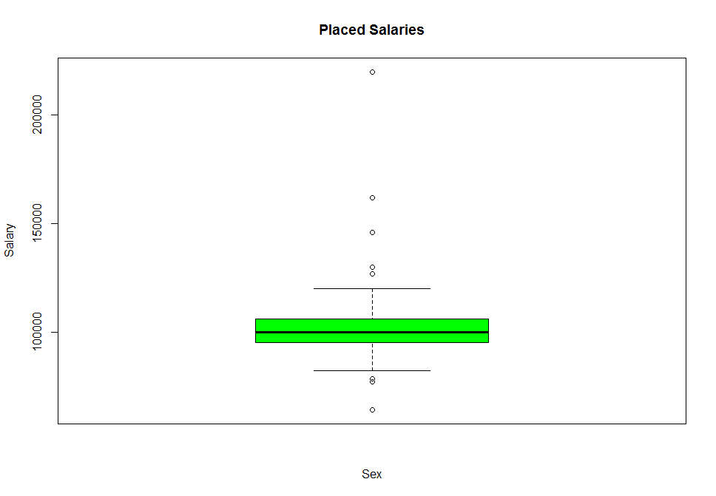



> StartSalLM_3 <-lm(salary~sex+gmat_tot+gmat_tpc

+ +quarter+work_yrs+frstlang, data = MBASal.df)

> StartSalLM_3

Call:

lm(formula = salary ~ sex + gmat_tot + gmat_tpc + quarter + work_yrs +

frstlang, data = MBASal.df)

Coefficients:

(Intercept) sex gmat_tot gmat_tpc quarter work_yrs frstlang

141371.6 4295.8 -206.5 646.1 -7317.9 -289.0 -13366.9

>

> summary(StartSalLM_3)

Call:

lm(formula = salary ~ sex + gmat_tot + gmat_tpc + quarter + work_yrs +

frstlang, data = MBASal.df)

Residuals:

Min 1Q Median 3Q Max

-59160 -39289 -27343 51485 200683

Coefficients:

Estimate Std. Error t value Pr(>|t|)

(Intercept) 141371.6 44869.7 3.151 0.00181 **

sex 4295.8 7125.5 0.603 0.54710

gmat_tot -206.5 100.8 -2.048 0.04154 *

gmat_tpc 646.1 410.2 1.575 0.11639

quarter -7317.9 2803.8 -2.610 0.00957 **

work_yrs -289.0 964.0 -0.300 0.76456

frstlang -13366.9 9584.4 -1.395 0.16428

---

Signif. codes: 0 ‘***’ 0.001 ‘**’ 0.01 ‘*’ 0.05 ‘.’ 0.1 ‘ ’ 1

Residual standard error: 50230 on 267 degrees of freedom

Multiple R-squared: 0.04956, Adjusted R-squared: 0.0282

F-statistic: 2.32 on 6 and 267 DF, p-value: 0.03352

|  |
| --- |
| > fitted(StartSalLM)  1 2 3 4 5 6 7 8 9  67213.43182 63066.97504 58074.33736 64689.41357 52169.34641 62151.45437 65903.13129 60544.99264 53724.78017  10 11 12 13 14 15 16 17 18  9613.43557 -4045.68903 19043.73530 4161.55659 -35.62635 14405.87936 15873.35335 8133.31467 8080.15346  19 20 21 22 23 24 25 26 27  13163.67112 17838.18427 66624.29684 42513.89035 32388.23498 60750.05089 61762.61326 64453.00783 55355.35607  28 29 30 31 32 33 34 35 36  37879.06355 55185.02264 15098.81474 62132.65779 54054.14689 54555.71220 46469.94683 62572.14889 56605.75292  37 38 39 40 41 42 43 44 45  63383.31427 62275.16524 49405.31293 52993.19095 58485.72097 62020.26086 58291.48032 58153.43519 61077.53879  46 47 48 49 50 51 52 53 54  66470.70906 60929.87020 57011.90353 64521.48851 60329.46716 64465.01590 65196.17004 57658.21394 61369.92198  55 56 57 58 59 60 61 62 63  55720.35403 56913.98093 64061.55187 65133.29276 61831.15929 51334.87557 59998.47817 52555.47349 45408.10689  64 65 66 67 68 69 70 71 72  63344.37684 49895.94817 63924.15550 55538.00667 75918.66428 54002.32007 57665.72956 56084.58791 51044.23666  73 74 75 76 77 78 79 80 81  54482.44587 54109.32467 55665.27357 49670.61698 48198.29846 45600.82942 304.33781 4764.69378 14456.46733  82 83 84 85 86 87 88 89 90  -4051.66386 4484.74061 992.82633 4269.20440 17619.32726 48970.20973 56232.87673 54972.09229 44123.15316  91 92 93 94 95 96 97 98 99  33925.15201 38414.80596 53963.34756 10378.59679 7371.58324 -4128.85401 57847.27387 58831.04563 51929.39189  100 101 102 103 104 105 106 107 108  53982.18324 51227.51323 48076.83487 59218.39307 48476.56121 53105.62187 53648.66437 47780.95554 47036.50535  109 110 111 112 113 114 115 116 117  68178.51642 44618.35204 41680.65432 52926.12395 38910.61838 43784.65406 52184.18562 56294.97915 48065.58316  118 119 120 121 122 123 124 125 126  49896.67032 56320.75560 52004.80157 57077.54535 56334.42262 56841.60541 51006.25371 49298.88700 56388.79989  127 128 129 130 131 132 133 134 135  53939.58056 56294.97915 57445.83105 53675.98845 45572.93354 56500.34266 43938.12920 53328.54334 48447.99891  136 137 138 139 140 141 142 143 144  54932.10733 52437.43831 51823.58264 56179.17028 36292.09453 40755.10589 37059.77566 42467.37902 38696.78183  145 146 147 148 149 150 151 152 153  42869.86410 49433.72171 50793.13456 -1249.97713 1469.84202 46756.15436 34536.48294 42652.32408 -9144.03836  154 155 156 157 158 159 160 161 162  -6857.45739 -2078.06724 -8515.16297 265.04859 41769.10276 41975.05669 43695.13402 35802.45486 48136.43529  163 164 165 166 167 168 169 170 171  50240.10108 45006.76217 48550.11808 29784.59747 37747.09164 44547.05642 44763.99927 40616.92992 -897.72581  172 173 174 175 176 177 178 179 180  -5172.35370 -760.37541 -7970.32651 1894.29685 -2864.66276 -11796.90363 -917.05505 36875.22807 42189.11465  181 182 183 184 185 186 187 188 189  42799.46603 42023.80405 40154.70254 39076.20433 22737.67668 46024.44775 46498.78797 48242.56365 47203.70483  190 191 192 193 194 195 196 197 198  49582.66648 46801.63999 47865.30556 45698.54577 43083.04260 44471.06660 47761.20120 35983.94258 45532.57957  199 200 201 202 203 204 205 206 207  29673.45933 35337.37141 51156.88159 53237.86723 39828.92552 39223.92818 50814.38939 34142.18336 31286.16582  208 209 210 211 212 213 214 215 216  43804.52144 42596.02331 -4158.78676 -5075.37964 33469.71412 21402.08372 41065.12859 10830.01017 -6760.49679  217 218 219 220 221 222 223 224 225  31352.31737 30774.60416 42531.57753 27832.86033 30471.84310 39676.87348 39824.96355 -1915.97729 -6536.18430  226 227 228 229 230 231 232 233 234  36491.87400 41163.41862 3834.03269 38645.35456 42525.57790 47108.46065 35708.82870 41852.44384 41812.56943  235 236 237 238 239 240 241 242 243  38906.95567 24179.24952 -10371.72339 34564.80669 28994.85534 41305.60734 36042.09535 27615.62875 33997.42907  244 245 246 247 248 249 250 251 252  38297.86523 27301.94599 33560.36833 -6410.50972 -5262.43622 -33949.59758 40309.45380 34565.75703 31308.90777  253 254 255 256 257 258 259 260 261  26416.04614 33001.33801 30755.46687 42483.74019 33554.39987 28807.71198 43743.94911 40293.96230 37829.10167  262 263 264 265 266 267 268 269 270  38622.82872 40675.81211 40920.73138 39016.15694 42086.40071 39261.94312 37745.63180 40845.43744 27921.84640  271 272 273 274  40721.49530 40671.55384 39020.52381 18833.71393  > fitted(StartSalLM_2)  1 2 3 4 5 6 7 8 9 10 11  57804.198 57966.827 48700.213 51163.457 44633.706 50984.575 58216.031 56375.311 37514.607 46713.383 32910.608  12 13 14 15 16 17 18 19 20 21 22  59576.740 39372.479 38241.266 52987.764 52027.692 48935.852 40335.499 51745.548 56064.866 61479.313 32269.279  23 24 25 26 27 28 29 30 31 32 33  15123.134 61511.812 50653.080 53601.044 57721.615 26154.371 49238.237 14135.686 56521.350 52146.555 51207.903  34 35 36 37 38 39 40 41 42 43 44  52930.551 56029.741 48344.799 50024.282 54451.376 40239.734 48331.545 46356.416 56222.176 54163.008 48559.116  45 46 47 48 49 50 51 52 53 54 55  54667.960 57340.325 56275.305 51499.462 53670.685 54468.038 54729.993 57678.529 49370.092 55372.664 45756.429  56 57 58 59 60 61 62 63 64 65 66  51392.819 55838.469 55860.685 56973.011 50728.142 57337.888 40417.572 34616.895 51283.972 42287.683 55421.865  67 68 69 70 71 72 73 74 75 76 77  51489.046 48398.579 43867.822 50007.507 46842.299 35973.835 50124.366 46806.181 51546.246 43048.011 40097.561  78 79 80 81 82 83 84 85 86 87 88  35412.792 34054.829 38110.732 51831.046 26132.302 39419.783 36898.047 41026.266 50218.869 39241.945 51616.358  89 90 91 92 93 94 95 96 97 98 99  49840.386 33512.156 25450.948 30734.860 43444.017 46473.592 44286.881 38528.480 48365.638 54115.307 44512.825  100 101 102 103 104 105 106 107 108 109 110  43926.905 36849.586 44662.026 51736.212 47453.501 45940.650 48936.212 39419.732 38791.677 45998.020 40064.351  111 112 113 114 115 116 117 118 119 120 121  38571.985 47797.732 41031.738 42874.443 45192.780 52818.084 44142.656 41999.802 48402.418 43287.001 51745.999  122 123 124 125 126 127 128 129 130 131 132  47746.716 50124.366 40670.950 39637.216 52283.750 47044.548 52818.084 48985.361 48150.900 35698.635 47819.143  133 134 135 136 137 138 139 140 141 142 143  46369.404 47831.252 40431.302 47020.468 42134.444 43810.377 47045.278 22798.728 30165.255 26106.057 34624.730  144 145 146 147 148 149 150 151 152 153 154  31878.863 36136.621 41667.421 43587.275 41168.824 37301.358 41070.333 25689.261 35885.643 24166.663 28171.530  155 156 157 158 159 160 161 162 163 164 165  33782.286 20073.220 38586.941 36862.487 37348.906 36110.348 26132.078 39413.646 41000.952 35970.421 44786.528  166 167 168 169 170 171 172 173 174 175 176  19954.890 24528.711 43027.418 43694.601 29608.984 37540.837 33782.528 35827.341 29114.670 40834.943 39835.377  177 178 179 180 181 182 183 184 185 186 187  20578.000 40652.013 33992.797 29220.610 36697.522 36983.175 38280.887 38792.465 32792.993 39122.842 38955.928  188 189 190 191 192 193 194 195 196 197 198  42441.617 35922.525 42964.313 43824.300 38718.224 39348.575 36973.731 37486.925 44824.090 18847.173 40753.281  199 200 201 202 203 204 205 206 207 208 209  24122.154 26142.506 43977.868 49094.518 35174.151 30762.054 43355.515 26135.619 18397.096 36458.234 32377.058  210 211 212 213 214 215 216 217 218 219 220  33707.491 31256.980 25743.612 12840.610 34389.850 28331.582 30807.234 20206.002 20526.944 28925.973 23493.380  221 222 223 224 225 226 227 228 229 230 231  21165.255 31353.728 35038.847 35076.549 31713.553 28474.071 35806.557 -5801.216 34005.984 34694.860 34611.055  232 233 234 235 236 237 238 239 240 241 242  24276.070 32578.332 35288.051 33564.518 17292.184 -9336.474 24085.564 22229.273 31720.471 25535.450 14831.485  243 244 245 246 247 248 249 250 251 252 253  28239.885 29947.789 18728.298 26458.117 29450.915 36086.535 9534.433 33077.070 27644.900 19372.411 18033.539  254 255 256 257 258 259 260 261 262 263 264  32661.286 23149.768 33806.696 25977.298 20779.476 31675.550 35938.189 29199.988 27905.881 34170.982 33114.581  265 266 267 268 269 270 271 272 273 274  32910.870 38138.104 34747.058 27381.323 33899.702 19699.189 30722.837 34822.054 33610.673 19941.896  > fitted(StartSalLM_3)  1 2 3 4 5 6 7 8 9 10  56872.014 54641.374 47419.299 55437.801 45392.808 51030.336 54641.374 53907.070 38436.387 46000.255  11 12 13 14 15 16 17 18 19 20  35547.715 58291.058 40808.034 39677.988 52556.124 55972.206 53202.217 41112.334 51803.287 53544.143  21 22 23 24 25 26 27 28 29 30  60158.771 35258.717 20404.676 58312.067 54732.949 51709.244 57259.456 30550.448 49585.348 6113.828  31 32 33 34 35 36 37 38 39 40  55427.026 57548.454 51374.188 49115.135 53423.117 47457.945 50296.032 54264.165 41097.031 56005.021  41 42 43 44 45 46 47 48 49 50  47997.294 59860.436 58370.827 50546.384 58612.870 54553.163 54629.568 52839.290 50257.386 54467.428  51 52 53 54 55 56 57 58 59 60  54859.806 55021.946 53255.145 53992.813 50842.251 49140.041 52806.475 53833.141 54170.122 50076.170  61 62 63 64 65 66 67 68 69 70  54570.808 41386.029 36897.356 53833.141 42295.175 53901.238 49981.089 49338.503 43451.166 47093.250  71 72 73 74 75 76 77 78 79 80  44358.543 35295.728 47830.918 45547.349 52483.790 41520.456 39328.462 37620.421 31676.383 37909.419  81 82 83 84 85 86 87 88 89 90  49138.273 27380.606 39328.462 36974.328 40101.413 47704.060 39039.465 51964.554 47668.777 33747.359  91 92 93 94 95 96 97 98 99 100  28229.829 31493.109 47288.205 43907.405 47379.780 42934.554 45972.542 50106.179 42234.647 41809.454  101 102 103 104 105 106 107 108 109 110  35051.351 46432.883 48365.323 45232.406 46421.212 47126.065 38104.374 40169.510 48372.192 45831.411  111 112 113 114 115 116 117 118 119 120  42241.517 50543.043 38315.536 40439.433 44686.187 49554.128 45831.411 40101.413 46388.397 47957.775  121 122 123 124 125 126 127 128 129 130  47426.734 47577.203 47830.918 38470.797 38412.037 51999.837 47379.780 49554.128 45615.447 47379.780  131 132 133 134 135 136 137 138 139 140  38393.371 46261.540 44038.665 46804.252 38945.422 45547.349 43907.405 42361.504 45258.351 25331.214  141 142 143 144 145 146 147 148 149 150  27969.534 27107.352 33429.620 31403.129 35910.612 39775.364 40690.341 38908.371 37167.515 40477.749  151 152 153 154 155 156 157 158 159 160  26750.257 33913.573 23511.617 27272.989 32851.624 20546.673 37524.610 35816.569 40061.894 40247.511  161 162 163 164 165 166 167 168 169 170  25541.471 44519.811 39070.511 35621.614 44773.526 23555.075 25414.614 40596.299 44714.766 28869.342  171 172 173 174 175 176 177 178 179 180  39197.369 35332.616 40639.889 38781.514 39843.462 38100.003 21676.719 43077.291 38085.864 26603.419  181 182 183 184 185 186 187 188 189 190  40707.987 40613.944 36758.530 36469.532 33936.515 44439.908 37651.468 41678.360 37167.515 39427.607  191 192 193 194 195 196 197 198 199 200  44068.673 38008.563 40097.177 37725.397 44935.666 44681.951 18643.676 38781.514 25662.364 26818.355  201 202 203 204 205 206 207 208 209 210  41463.292 45074.330 33114.677 32273.629 40386.174 30208.492 20835.670 39935.036 32010.576 32041.623  211 212 213 214 215 216 217 218 219 220  29365.676 32814.574 15659.193 32310.507 29365.676 32652.433 19574.531 21497.508 27530.777 30908.974  221 222 223 224 225 226 227 228 229 230  19666.106 32168.480 32906.148 32652.433 29472.420 26306.689 38263.873 2690.378 30563.820 33357.286  231 232 233 234 235 236 237 238 239 240  32203.763 24598.648 32779.291 33101.103 30333.582 18633.476 -16128.827 31900.492 21182.565 29560.631  241 242 243 244 245 246 247 248 249 250  25176.643 16771.727 27764.379 28303.728 19214.968 23879.646 28404.640 32558.391 11860.070 33484.144  251 252 253 254 255 256 257 258 259 260  28277.783 19250.250 17784.118 31461.160 24637.294 36971.687 27530.777 21731.109 31914.766 34502.501  261 262 263 264 265 266 267 268 269 270  27436.735 27530.777 32041.623 32168.480 33195.146 37110.350 32599.505 29560.631 30852.817 19111.587  271 272 273 274  33068.288 32640.627 33159.863 19316.775  >  > residuals(StartSalLM)  1 2 3 4 5 6 7 8  -67213.431821 -63066.975045 -58074.337356 -64689.413567 -51170.346406 -62151.454374 -65903.131294 -60544.992642  9 10 11 12 13 14 15 16  -52725.780173 -8615.435573 5043.689027 -18045.735299 -3163.556594 1033.626347 -13407.879358 -14875.353350  17 18 19 20 21 22 23 24  -7135.314672 -7082.153463 -12165.671116 -16840.184270 -65625.296837 -42513.890354 -32388.234984 -60750.050892  25 26 27 28 29 30 31 32  -61762.613263 -63454.007831 -55355.356074 -37879.063550 -55185.022637 -14099.814738 -62132.657787 -54054.146891  33 34 35 36 37 38 39 40  -54555.712197 -46469.946826 22427.851112 28394.247083 22616.685731 25724.834763 42594.687071 40006.809051  41 42 43 44 45 46 47 48  36514.279027 32979.739142 36708.519684 37846.564813 34922.461214 33529.290943 39070.129803 42988.096466  49 50 51 52 53 54 55 56  40478.511495 44670.532844 40534.984098 39803.829959 47341.786065 43630.078020 50279.645974 49086.019074  57 58 59 60 61 62 63 64  43438.448128 42866.707241 48168.840708 60665.124431 55001.521833 62444.526515 72591.893110 56655.623157  65 66 67 68 69 70 71 72  70104.051829 56075.844499 64461.993330 70081.335719 107997.679931 -57665.729560 -56084.587910 -51044.236656  73 74 75 76 77 78 79 80  -54482.445868 -54109.324667 -55665.273567 -49670.616983 -48198.298457 -44601.829419 693.662193 -3766.693781  81 82 83 84 85 86 87 88  -13458.467327 5049.663865 -3486.740606 5.173668 -3271.204402 -16621.327263 -47971.209730 -56232.876725  89 90 91 92 93 94 95 96  -54972.092287 -44123.153161 -32926.152011 -38414.805960 -53963.347557 -9380.596785 -6373.583235 5126.854013  97 98 99 100 101 102 103 104  -57847.273869 -58831.045633 -50930.391892 -53982.183237 -50228.513235 -48076.834866 -59218.393072 -48476.561206  105 106 107 108 109 110 111 112  -52106.621866 -53648.664373 -47780.955539 -46037.505348 -68178.516421 -44618.352041 -41680.654321 -52926.123946  113 114 115 116 117 118 119 120  -38910.618379 -43784.654063 29815.814378 35705.020846 44934.416838 45103.329678 38679.244401 43995.198433  121 122 123 124 125 126 127 128  39422.454648 41665.577381 41158.394587 46993.746294 49701.112995 43611.200107 46060.419437 44705.020846  129 130 131 132 133 134 135 136  45554.168949 50324.011545 59427.066457 48499.657341 61061.870803 53671.456658 63552.001091 60067.892668  137 138 139 140 141 142 143 144  62562.561686 78176.417359 89620.829718 -36292.094529 -40755.105894 -37059.775660 -42467.379022 -38696.781833  145 146 147 148 149 150 151 152  -41870.864099 -49433.721710 -50793.134561 2247.977131 -471.842021 -46756.154357 -34536.482935 -41653.324076  153 154 155 156 157 158 159 160  10142.038355 7855.457388 3076.067241 9513.162973 732.951415 -40770.102761 -41975.056688 -43695.134018  161 162 163 164 165 166 167 168  -34803.454860 -48136.435291 -50240.101083 -45006.762169 -48550.118081 -28785.597475 -37747.091635 -44547.056425  169 170 171 172 173 174 175 176  -44763.999266 -39617.929921 1895.725814 6170.353702 1758.375409 8968.326508 -896.296854 3862.662756  177 178 179 180 181 182 183 184  12794.903627 1915.055047 -35876.228067 -42189.114650 -41800.466034 -42023.804053 -40154.702541 -39076.204326  185 186 187 188 189 190 191 192  -22737.676684 32231.552249 42001.212031 41757.436355 42796.295168 43417.333522 48198.360013 49134.694441  193 194 195 196 197 198 199 200  51301.454231 54916.957400 53528.933402 50238.798799 62016.057420 52467.420430 68326.540668 64662.628590  201 202 203 204 205 206 207 208  48843.118414 47762.132768 61271.074481 63276.071815 54185.610611 71857.816645 76013.834184 64195.478564  209 210 211 212 213 214 215 216  69403.976690 5156.786763 6073.379643 -32470.714121 -21402.083720 -40066.128593 -9832.010168 7758.496786  217 218 219 220 221 222 223 224  -30353.317373 -30774.604165 -42531.577525 -27832.860332 -29472.843099 -39676.873481 -38825.963553 2913.977292  225 226 227 228 229 230 231 232  7534.184299 -35492.874003 -41163.418622 -2835.032692 -38645.354561 -42525.577903 -46109.460650 -35708.828698  233 234 235 236 237 238 239 240  -41852.443835 -41812.569432 -37907.955672 -24179.249523 10371.723388 -34564.806693 -27995.855342 -40306.607337  241 242 243 244 245 246 247 248  -36042.095350 -27615.628745 -33997.429067 -38297.865229 -26302.945995 -32561.368326 7408.509716 6260.436218  249 250 251 252 253 254 255 256  34947.597582 -40309.453796 -33566.757028 -30309.907774 -26416.046142 -33001.338005 -30755.466872 21516.259807  257 258 259 260 261 262 263 264  43445.600129 56192.288022 41256.050888 45706.037700 52170.898332 53377.171283 54324.187892 55079.268621  265 266 267 268 269 270 271 272  58983.843064 57913.599289 60738.056884 62654.368199 60754.562563 76078.153596 64278.504703 74328.446163  273 274  87689.476189 201166.286070  > residuals(StartSalLM_2)  1 2 3 4 5 6 7 8 9 10  -57804.198 -57966.827 -48700.213 -51163.457 -43634.706 -50984.575 -58216.031 -56375.311 -36515.607 -45715.383  11 12 13 14 15 16 17 18 19 20  -31912.608 -58578.740 -38374.479 -37243.266 -51989.764 -51029.692 -47937.852 -39337.499 -50747.548 -55066.866  21 22 23 24 25 26 27 28 29 30  -60480.313 -32269.279 -15123.134 -61511.812 -50653.080 -52602.044 -57721.615 -26154.371 -49238.237 -13136.686  31 32 33 34 35 36 37 38 39 40  -56521.350 -52146.555 -51207.903 -52930.551 28970.259 36655.201 35975.718 33548.624 51760.266 44668.455  41 42 43 44 45 46 47 48 49 50  48643.584 38777.824 40836.992 47440.884 41332.040 42659.675 43724.695 48500.538 51329.315 50531.962  51 52 53 54 55 56 57 58 59 60  50270.007 47321.471 55629.908 49627.336 60243.571 54607.181 51661.531 52139.315 53026.989 61271.858  61 62 63 64 65 66 67 68 69 70  57662.112 74582.428 83383.105 68716.028 77712.317 64578.135 68510.954 97601.421 118132.178 -50007.507  71 72 73 74 75 76 77 78 79 80  -46842.299 -35973.835 -50124.366 -46806.181 -51546.246 -43048.011 -40097.561 -34413.792 -33056.829 -37112.732  81 82 83 84 85 86 87 88 89 90  -50833.046 -25134.302 -38421.783 -35900.047 -40028.266 -49220.869 -38242.945 -51616.358 -49840.386 -33512.156  91 92 93 94 95 96 97 98 99 100  -24451.948 -30734.860 -43444.017 -45475.592 -43288.881 -37530.480 -48365.638 -54115.307 -43513.825 -43926.905  101 102 103 104 105 106 107 108 109 110  -35850.586 -44662.026 -51736.212 -47453.501 -44941.650 -48936.212 -39419.732 -37792.677 -45998.020 -40064.351  111 112 113 114 115 116 117 118 119 120  -38571.985 -47797.732 -41031.738 -42874.443 36807.220 39181.916 48857.344 53000.198 46597.582 52712.999  121 122 123 124 125 126 127 128 129 130  44754.001 50253.284 47875.634 57329.050 59362.784 47716.250 52955.452 48181.916 54014.639 55849.100  131 132 133 134 135 136 137 138 139 140  69301.365 57180.857 58630.596 59168.748 71568.698 67979.532 72865.556 86189.623 98754.722 -22798.728  141 142 143 144 145 146 147 148 149 150  -30165.255 -26106.057 -34624.730 -31878.863 -35137.621 -41667.421 -43587.275 -40170.824 -36303.358 -41070.333  151 152 153 154 155 156 157 158 159 160  -25689.261 -34886.643 -23168.663 -27173.530 -32784.286 -19075.220 -37588.941 -35863.487 -37348.906 -36110.348  161 162 163 164 165 166 167 168 169 170  -25133.078 -39413.646 -41000.952 -35970.421 -44786.528 -18955.890 -24528.711 -43027.418 -43694.601 -28609.984  171 172 173 174 175 176 177 178 179 180  -36542.837 -32784.528 -34829.341 -28116.670 -39836.943 -38837.377 -19580.000 -39654.013 -32993.797 -29220.610  181 182 183 184 185 186 187 188 189 190  -35698.522 -36983.175 -38280.887 -38792.465 -32792.993 39133.158 49544.072 47558.383 54077.475 50035.687  191 192 193 194 195 196 197 198 199 200  51175.700 58281.776 57651.425 61026.269 60513.075 53175.910 79152.827 57246.719 73877.846 73857.494  201 202 203 204 205 206 207 208 209 210  56022.132 51905.482 65925.849 71737.946 61644.485 79864.381 88902.904 71541.766 79622.942 -32709.491  211 212 213 214 215 216 217 218 219 220  -30258.980 -24744.612 -12840.610 -33390.850 -27333.582 -29809.234 -19207.002 -20526.944 -28925.973 -23493.380  221 222 223 224 225 226 227 228 229 230  -20166.255 -31353.728 -34039.847 -34078.549 -30715.553 -27475.071 -35806.557 6800.216 -34005.984 -34694.860  231 232 233 234 235 236 237 238 239 240  -33612.055 -24276.070 -32578.332 -35288.051 -32565.518 -17292.184 9336.474 -24085.564 -21230.273 -30721.471  241 242 243 244 245 246 247 248 249 250  -25535.450 -14831.485 -28239.885 -29947.789 -17729.298 -25459.117 -28452.915 -35088.535 -8536.433 -33077.070  251 252 253 254 255 256 257 258 259 260  -26645.900 -18373.411 -18033.539 -32661.286 -23149.768 30193.304 51022.702 64220.524 53324.450 50061.811  261 262 263 264 265 266 267 268 269 270  60800.012 64094.119 60829.018 62885.419 65089.130 61861.896 65252.942 73018.677 67700.298 84300.811  271 272 273 274  74277.163 80177.946 93099.327 200058.104  > residuals(StartSalLM_3)  1 2 3 4 5 6 7 8 9 10  -56872.014 -54641.374 -47419.299 -55437.801 -44393.808 -51030.336 -54641.374 -53907.070 -37437.387 -45002.255  11 12 13 14 15 16 17 18 19 20  -34549.715 -57293.058 -39810.034 -38679.988 -51558.124 -54974.206 -52204.217 -40114.334 -50805.287 -52546.143  21 22 23 24 25 26 27 28 29 30  -59159.771 -35258.717 -20404.676 -58312.067 -54732.949 -50710.244 -57259.456 -30550.448 -49585.348 -5114.828  31 32 33 34 35 36 37 38 39 40  -55427.026 -57548.454 -51374.188 -49115.135 31576.883 37542.055 35703.968 33735.835 50902.969 36994.979  41 42 43 44 45 46 47 48 49 50  47002.706 35139.564 36629.173 45453.616 37387.130 45446.837 45370.432 47160.710 54742.614 50532.572  51 52 53 54 55 56 57 58 59 60  50140.194 49978.054 51744.855 51007.187 55157.749 56859.959 54693.525 54166.859 55829.878 61923.830  61 62 63 64 65 66 67 68 69 70  60429.192 73613.971 81102.644 66166.859 77704.825 66098.762 70018.911 96661.497 118548.834 -47093.250  71 72 73 74 75 76 77 78 79 80  -44358.543 -35295.728 -47830.918 -45547.349 -52483.790 -41520.456 -39328.462 -36621.421 -30678.383 -36911.419  81 82 83 84 85 86 87 88 89 90  -48140.273 -26382.606 -38330.462 -35976.328 -39103.413 -46706.060 -38040.465 -51964.554 -47668.777 -33747.359  91 92 93 94 95 96 97 98 99 100  -27230.829 -31493.109 -47288.205 -42909.405 -46381.780 -41936.554 -45972.542 -50106.179 -41235.647 -41809.454  101 102 103 104 105 106 107 108 109 110  -34052.351 -46432.883 -48365.323 -45232.406 -45422.212 -47126.065 -38104.374 -39170.510 -48372.192 -45831.411  111 112 113 114 115 116 117 118 119 120  -42241.517 -50543.043 -38315.536 -40439.433 37313.813 42445.872 47168.589 54898.587 48611.603 48042.225  121 122 123 124 125 126 127 128 129 130  49073.266 50422.797 50169.082 59529.203 60587.963 48000.163 52620.220 51445.872 57384.553 56620.220  131 132 133 134 135 136 137 138 139 140  66606.629 58738.460 60961.335 60195.748 73054.578 69452.651 71092.595 87638.496 100541.649 -25331.214  141 142 143 144 145 146 147 148 149 150  -27969.534 -27107.352 -33429.620 -31403.129 -34911.612 -39775.364 -40690.341 -37910.371 -36169.515 -40477.749  151 152 153 154 155 156 157 158 159 160  -26750.257 -32914.573 -22513.617 -26274.989 -31853.624 -19548.673 -36526.610 -34817.569 -40061.894 -40247.511  161 162 163 164 165 166 167 168 169 170  -24542.471 -44519.811 -39070.511 -35621.614 -44773.526 -22556.075 -25414.614 -40596.299 -44714.766 -27870.342  171 172 173 174 175 176 177 178 179 180  -38199.369 -34334.616 -39641.889 -37783.514 -38845.462 -37102.003 -20678.719 -42079.291 -37086.864 -26603.419  181 182 183 184 185 186 187 188 189 190  -39708.987 -40613.944 -36758.530 -36469.532 -33936.515 33816.092 50848.532 48321.640 52832.485 53572.393  191 192 193 194 195 196 197 198 199 200  50931.327 58991.437 56902.823 60274.603 53064.334 53318.049 79356.324 59218.486 72337.636 73181.645  201 202 203 204 205 206 207 208 209 210  58536.708 55925.670 67985.323 70226.371 64613.826 75791.508 86464.330 68064.964 79989.424 -31043.623  211 212 213 214 215 216 217 218 219 220  -28367.676 -31815.574 -15659.193 -31311.507 -28367.676 -31654.433 -18575.531 -21497.508 -27530.777 -30908.974  221 222 223 224 225 226 227 228 229 230  -18667.106 -32168.480 -31907.148 -31654.433 -28474.420 -25307.689 -38263.873 -1691.378 -30563.820 -33357.286  231 232 233 234 235 236 237 238 239 240  -31204.763 -24598.648 -32779.291 -33101.103 -29334.582 -18633.476 16128.827 -31900.492 -20183.565 -28561.631  241 242 243 244 245 246 247 248 249 250  -25176.643 -16771.727 -27764.379 -28303.728 -18215.968 -22880.646 -27406.640 -31560.391 -10862.070 -33484.144  251 252 253 254 255 256 257 258 259 260  -27278.783 -18251.250 -17784.118 -31461.160 -24637.294 27028.313 49469.223 63268.891 53085.234 51497.499  261 262 263 264 265 266 267 268 269 270  62563.265 64469.223 62958.377 63831.520 64804.854 62889.650 67400.495 70839.369 70747.183 84888.413  271 272 273 274  71931.712 82359.373 93550.137 200683.225  >  > mean(residuals(StartSalLM))  [1] -1.305117e-12  > mean(residuals(StartSalLM_2))  [1] 1.145997e-12  > mean(residuals(StartSalLM_3))  [1] -3.268393e-12 |
|  |
| |  | | --- | | > | |

|  |
| --- |
| > t.test(placed.df$salary~placed.df$sex)  Welch Two Sample t-test  data: placed.df$salary by placed.df$sex  t = 1.3628, df = 38.115, p-value = 0.1809  alternative hypothesis: true difference in means is not equal to 0  95 percent confidence interval:  -3128.55 16021.72  sample estimates:  mean in group 1 mean in group 2  104970.97 98524.39  > t.test(placed.df$age~placed.df$sex)  Welch Two Sample t-test  data: placed.df$age by placed.df$sex  t = 1.4625, df = 57.378, p-value = 0.1491  alternative hypothesis: true difference in means is not equal to 0  95 percent confidence interval:  -0.3759495 2.4135840  sample estimates:  mean in group 1 mean in group 2  27.08333 26.06452  > t.test(placed.df$work_yrs~placed.df$sex)  Welch Two Sample t-test  data: placed.df$work_yrs by placed.df$sex  t = 0.97853, df = 63.885, p-value = 0.3315  alternative hypothesis: true difference in means is not equal to 0  95 percent confidence interval:  -0.6281501 1.8342433  sample estimates:  mean in group 1 mean in group 2  3.861111 3.258065 |
|  |
| |  | | --- | | > | |

|  |
| --- |
| > NotPlaced.df <- MBASal.df[ which(MBASal.df$salary!= '998' & MBASal.df$salary != '999'  + & MBASal.df$salary == '0') , ]  > head(NotPlaced.df)  age sex gmat_tot gmat_qpc gmat_vpc gmat_tpc s_avg f_avg quarter work_yrs frstlang salary satis  1 23 2 620 77 87 87 3.4 3.00 1 2 1 0 7  2 24 1 610 90 71 87 3.5 4.00 1 2 1 0 6  3 24 1 670 99 78 95 3.3 3.25 1 2 1 0 6  4 24 1 570 56 81 75 3.3 2.67 1 1 1 0 7  6 24 1 640 82 89 91 3.9 3.75 1 2 1 0 6  7 25 1 610 89 74 87 3.4 3.50 1 2 1 0 5  >  >  > boxplot(NotPlaced.df$salary~NotPlaced.df$sex,main = "Not Placed Salaries", xlab = "Sex"  + ,col = (c("green","red")), ylab = "Salary")  > boxplot(NotPlaced.df$gmat_tot~NotPlaced.df$sex,main = "Not Placed GMAT Total", xlab = "Sex"  + ,col = (c("green","red")), ylab = "Scores")  > boxplot(NotPlaced.df$gmat_qpc~NotPlaced.df$sex,main = "Not Placed GMAT Quant Percentile", xlab = "Sex"  + ,col = (c("green","red")), ylab = "Scores")  > boxplot(NotPlaced.df$gmat_vpc~NotPlaced.df$sex,main = "Not Placed GMAT Verbal Percentile", xlab = "Sex"  + ,col = (c("green","red")), ylab = "Scores")  > boxplot(NotPlaced.df$gmat_tpc~NotPlaced.df$sex,main = "Not Placed GMAT Total Percentile", xlab = "Sex"  + ,col = (c("green","red")), ylab = "Scores")  > boxplot(NotPlaced.df$age~NotPlaced.df$sex,main = "Not Placed Age vs Sex", xlab = "Sex"  + ,col = (c("green","red")), ylab = "Age")  > boxplot(NotPlaced.df$work_yrs~NotPlaced.df$sex,main = "Not Placed Work Experience", xlab = "Sex"  + ,col = (c("green","red")), ylab = "Years") |
|  |
| |  | | --- | | > | |

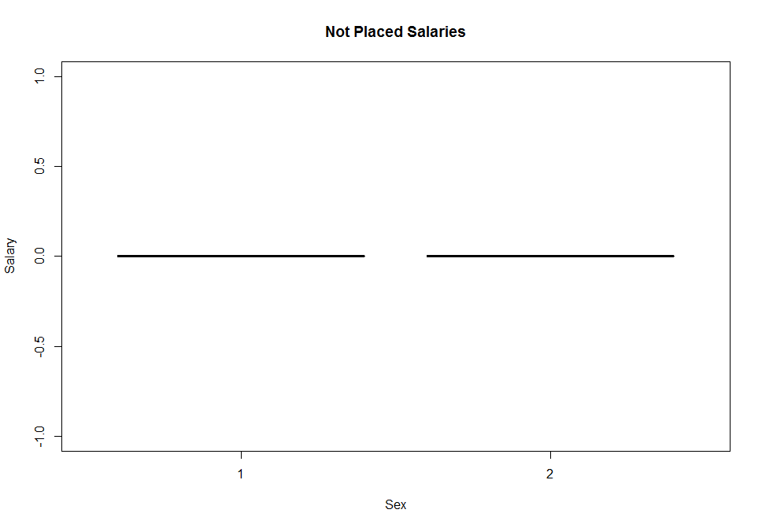 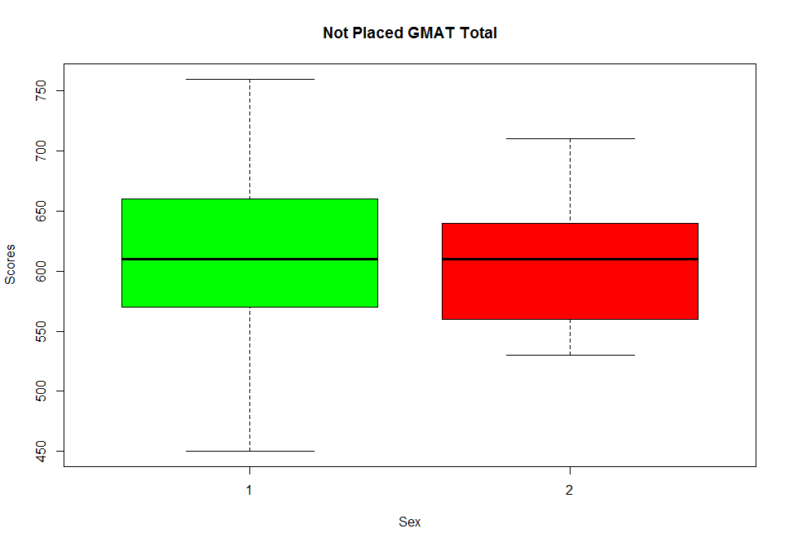 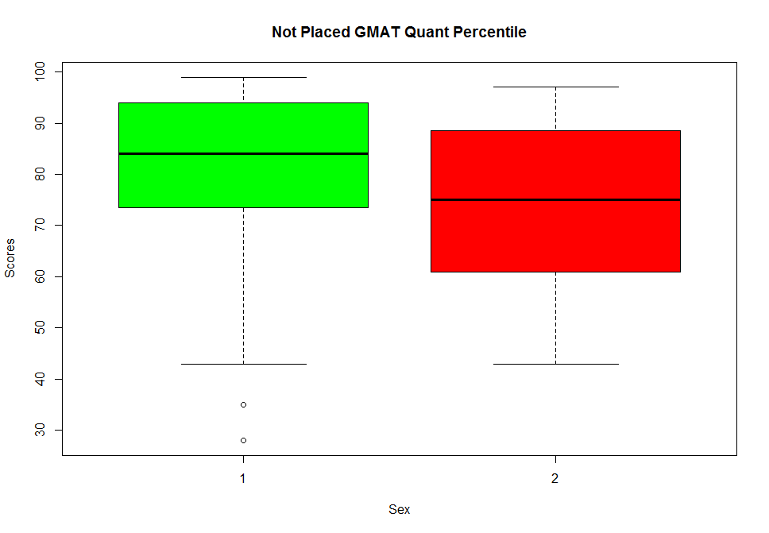 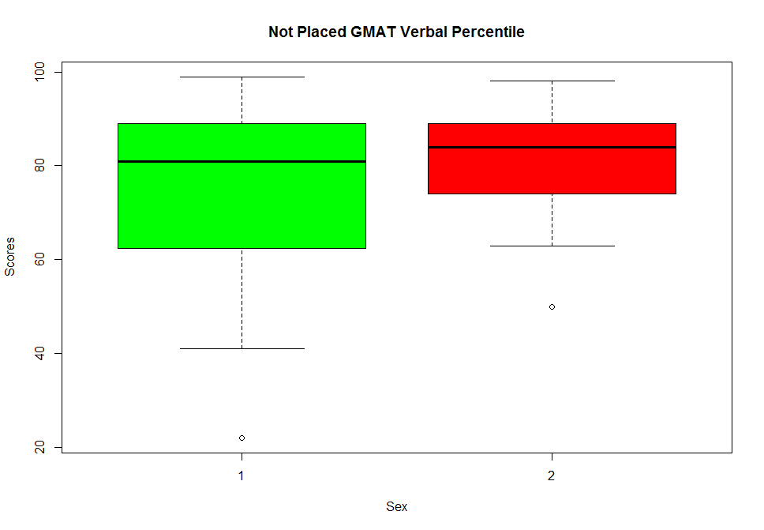 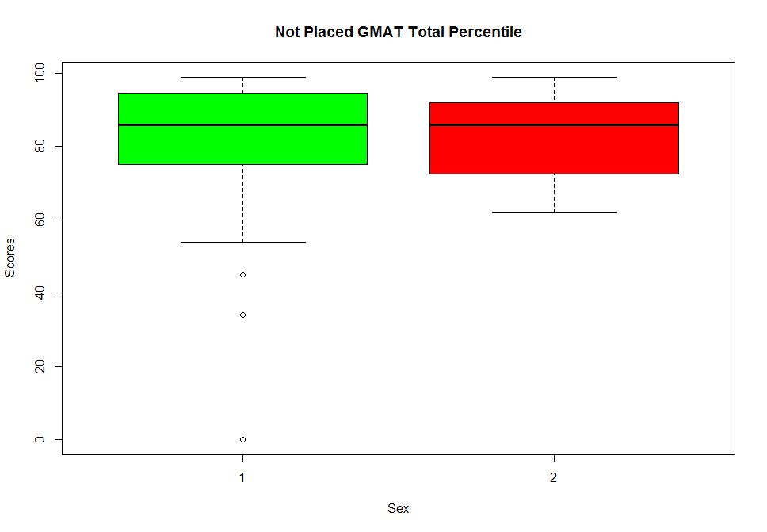 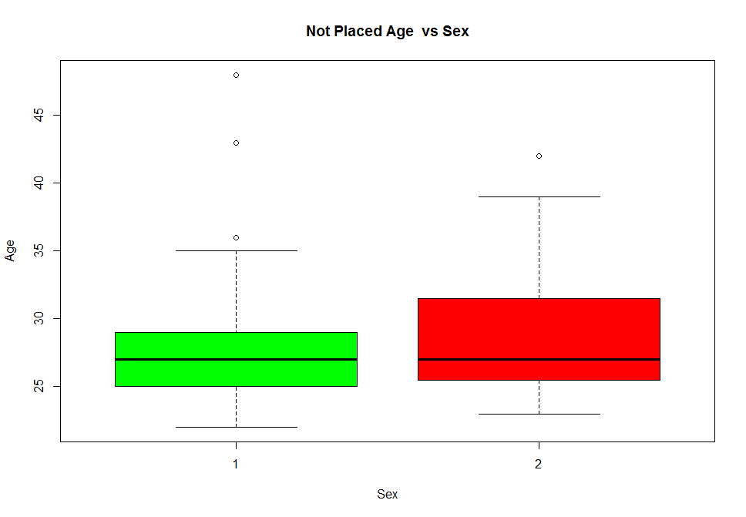 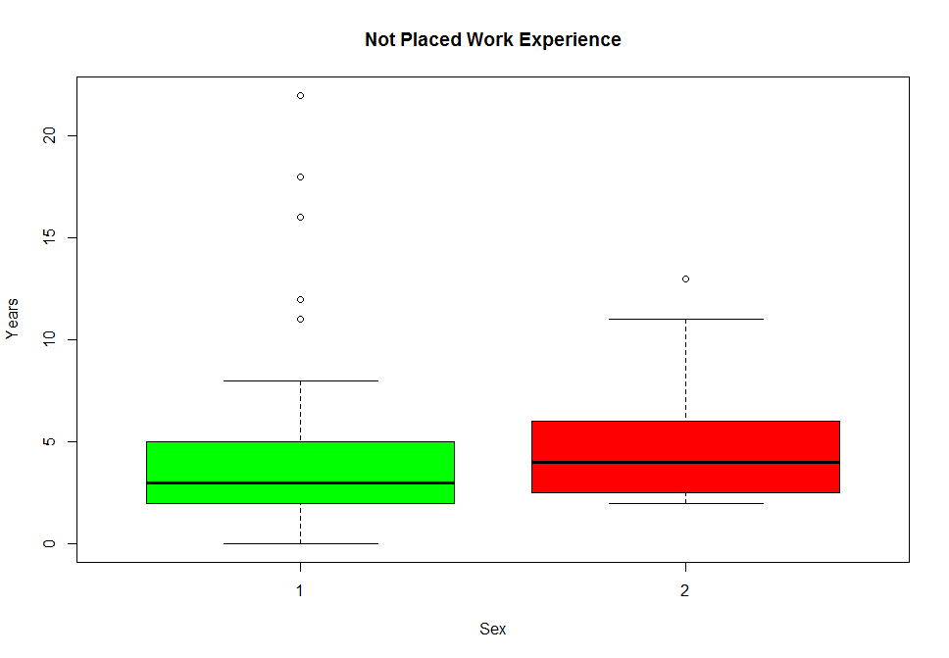

> library(lattice)

> histogram(~frstlang | sex, data=NotPlaced.df)

> histogram(~frstlang | sex, data=placed.df)

>

> ### This data set does not allow us to investigate what role the first language plays since an overwhelming

> ### majority in this data set have English as their first language. Hence this is data set is biased.

>

>

>

> #Chi Square Test

> mytable <- xtabs(~ sex, data=NotPlaced.df)

> mytable

sex

1 2

67 23

> chisq.test(mytable)

Chi-squared test for given probabilities

data: mytable

X-squared = 21.511, df = 1, p-value = 3.518e-06

>

> mytable <- xtabs(~ sex, data=placed.df)

> mytable

sex

1 2

72 31

> chisq.test(mytable)

Chi-squared test for given probabilities

data: mytable

X-squared = 16.32, df = 1, p-value = 5.349e-05

